
Holy Cross College

Semester 1 Examination 2017

Question/Answer Booklet

Please place your student identification label in this box
Year 10 Science
(Adjusted)

Student Name
Student’s Teacher

Time allowed for this paper

Reading time before commencing work: 10 minutes
Working time for paper: 100 minutes

Materials required/recommended for this paper

To be provided by the supervisor

This Question/Answer Booklet
Data Sheet

To be provided by the candidate

Standard items: pens, pencils, eraser, correction fluid, ruler, highlighters.
Special items: non-programmable calculators satisfying the conditions set by the School Curriculum and Standards Authority for this course.

Important note to candidates

No other items may be taken into the examination room. It is your responsibility to ensure that you do not have any unauthorised notes or other items of a non-personal nature in the examination room. If you have any unauthorised material with you, hand it to the supervisor before reading any further.

Structure of this paper

Section | Number of questions available | Number of questions to be answered | Suggested working time  (minutes) | Marks available | Percentage of exam
Section One:  Multiple Choice | 42 | 42 | 35 | 42 | 35
Section Two:  Short Answer | 13 | 13 | 45 | 68 | 57
Section Three:  Comprehension | 5 | 5 | 20 | 10 | 8
 |  |  |  | 120 | 100

Instructions to candidates

1. The rules for the conduct of examinations at Holy Cross College are detailed in the College Examination Policy. Sitting this examination implies that you agree to abide by these rules.

2. Write your answers in this Question/Answer Booklet.

3. Working or reasoning should be clearly shown when calculating or estimating answers.

4. You must be careful to confine your responses to the specific questions asked and to follow any instructions that are specific to a particular question.

5. Spare pages are included at the end of this booklet. They can be used for planning your responses and/or as additional space if required to continue an answer.

• Planning: If you use the spare pages for planning, indicate this clearly at the top of the page.
• Continuing an answer: If you need to use the space to continue an answer, indicate in the original answer space where the answer is continued, i.e. give the page number.
• Fill in the number of the question(s) that you are continuing to answer at the top of the page.

SECTION 1 MULTIPLE CHOICE (42 marks)

Choose the best answer for each question in the Multiple Choice Question booklet.

Mark your selection with a cross.

1 | (a) | (b) | (c) | (d) |  | 31 | (a) | (b) | (c) | (d)
2 | (a) | (b) | (c) | (d) |  | 32 | (a) | (b) | (c) | (d)
3 | (a) | (b) | (c) | (d) |  | 33 | (a) | (b) | (c) | (d)
4 | (a) | (b) | (c) | (d) |  | 34 | (a) | (b) | (c) | (d)
5 | (a) | (b) | (c) | (d) |  | 35 | (a) | (b) | (c) | (d)
6 | (a) | (b) | (c) | (d) |  | 36 | (a) | (b) | (c) | (d)
7 | (a) | (b) | (c) | (d) |  | 37 | (a) | (b) | (c) | (d)
8 | (a) | (b) | (c) | (d) |  | 38 | (a) | (b) | (c) | (d)
9 | (a) | (b) | (c) | (d) |  | 39 | (a) | (b) | (c) | (d)
10 | (a) | (b) | (c) | (d) |  | 40 | (a) | (b) | (c) | (d)
11 | (a) | (b) | (c) | (d) |  | 41 | (a) | (b) | (c) | (d)
12 | (a) | (b) | (c) | (d) |  | 42 | (a) | (b) | (c) | (d)
13 | (a) | (b) | (c) | (d)
14 | (a) | (b) | (c) | (d)
15 | (a) | (b) | (c) | (d)
16 | (a) | (b) | (c) | (d)
17 | (a) | (b) | (c) | (d)
18 | (a) | (b) | (c) | (d)
19 | (a) | (b) | (c) | (d)
20 | (a) | (b) | (c) | (d)
21 | (a) | (b) | (c) | (d)
22 | (a) | (b) | (c) | (d)
23 | (a) | (b) | (c) | (d)
24 | (a) | (b) | (c) | (d)
25 | (a) | (b) | (c) | (d)
26 | (a) | (b) | (c) | (d)
27 | (a) | (b) | (c) | (d)
28 | (a) | (b) | (c) | (d)
29 | (a) | (b) | (c) | (d)
30 | (a) | (b) | (c) | (d)

SECTION 2 SHORT ANSWER (68 marks)

Attempt all questions. Write your answers in the spaces provided.

1. Use the words listed below to complete the following sentences. (9 marks)

protostar | billion | Milky Way | giants | fusion
constellations | space | nebulae | expansion

Groups of stars form patterns that are called .

Our solar system is part of a large galaxy called the .

Clouds of dust and gas in interstellar space are called .

According to the Big Bang Theory, the universe is about 13.7 years old.

The first stage of the Big Bang involved the formation of time and .

Space then underwent rapid .

Stars are formed when gravity causes gas and dust to come together and heat up.

Eventually a is formed and then finally a star.

Stars like our sun evolve into red before they explode.

Stars generate their energy by nuclear in which hydrogen changes to helium.

2. Choose the correct definition for the term in the first column of the table below. Write the correct letter in the second column.
(6 marks)

TERM | CORRECT LETTER | DEFINITION
Black dwarf |  | A: Pattern formed by a group of stars.
Nova |  | B: Formed by the expansion of a star about  the size of our Sun.
Red giant |  | C: Remains of the death of a massive star.
Black hole |  | D: Small, dead star that emits no light.
Constellation |  | E: Final stage in the development of a star.
Protostar |  | F: Explosion of the outer layers of an average-  size star.

3. Astronomers have found an Earth-like planet orbiting a star called Mu Arae. It takes light 50 years to reach Earth from this star, travelling at 300,000 km/second.

(a) The best speed possible for a spaceship with our current technology is about
50,000 km/h, which is equal to about 15 km/second.

Do you think humankind will be able to get to Mu Arae in a reasonable time?
Give a reason for your answer. (2 marks)

(b) Describe ONE possible way in which humankind might be able to overcome the vast distances required to travel to nearby galaxies. It may be a theoretical or practical method.
(2 marks)

4. Stars begin life with the same beginning - a protostar of hydrogen gas forms under
gravity and generates heat to start a nuclear reaction. Once formed, it is the size of the star that determines its ultimate pathway to its "death".

(a) What is the name of the nuclear reaction that generates the heat of stars?
(1 mark)

f

(b) (i) What is the name of the major element in stars? (1 mark)

h

(ii) Describe what happens to this element to produce the energy generated by the nuclear reaction. (1 mark)

(c) Our Sun is an average size, and will continue to produce energy for how many more years?

billion years
(1 mark)

(d) Our Sun goes through the stages listed in the table below. Describe what is happening at each stage
(4 marks)

Stage of Lifecycle | Description of what is occurring
Sun | Producing huge amounts of heat and light.
red giant
nova
white
dwarf
black
dwarf

(e) Giant stars, after a supernova, become black holes. Describe one characteristic of a black hole.
(1 mark)

•

5. The diagram below shows the spectra (black lines) seen on the light coming from distant galaxies. Look at the "double lines" shown here. This shows the lines as seen in our laboratory.

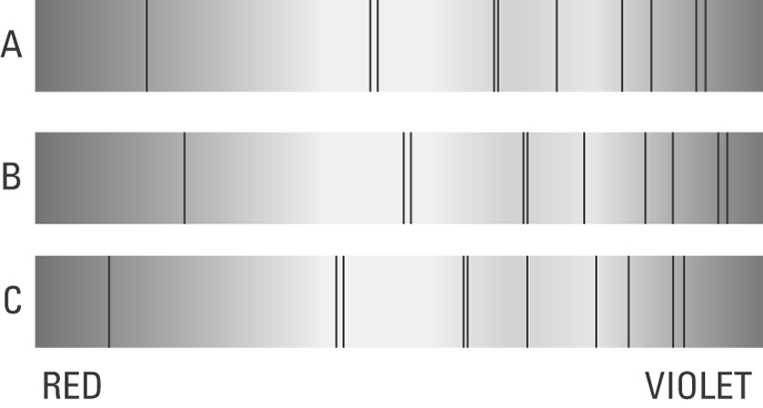

Look at B and C above and where the double lines have moved.

(a) Circle the lines that have been "red-shifted". (1 mark)

(b) Does "red-shift" mean the galaxy is moving towards us? Circle your answer.

YES NO (1 mark)

(d) Describe one thing that Edwin Hubble discovered about the movement of distant galaxies when he observed the light coming from them with his telescope.
(1 mark)
•

6. There are several theories on the origin of the universe. Each has its merits in explaining the observations made by astronomers on the universe as it appears now.

The currently accepted theory is the Big Bang Theory.

(a) An infinitely small point was present at the beginning of the universe. What is it called? (1 mark)

s

(b) Of what is this point made? (1 mark)

e

7. How long will it take to complete a trip by car from Perth to Kalgoorlie, a distance of 595 km, travelling at an average speed of 85 km/h? (Give your answer in hours.) (Hint: Use sp, d, t triangle.) (3 marks)

8. Vincent dropped a stone down a well and saw it hit the bottom 3.5 s later. Calculate the velocity of the stone at impact, given the acceleration due to gravity is 9.80 m/s² and the stone starts from rest. (Hint: Use v, u, a, t.) (3 marks)

9. A force of 36 N acts on a mass of 24 kg. What is the acceleration of the mass?
(Hint: Use F, m, a triangle.) (3 marks)

10. Consider the forces acting on the car in the diagram below. Calculate the nett force acting on the car. (2 marks)

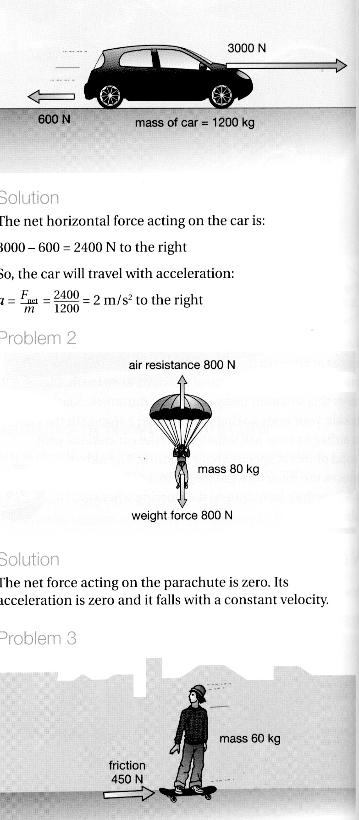

11. Max has a mass of 57 kg on Earth. He is lucky enough to be selected for a junior astronaut programme and journeys to the International Space Station (ISS) for a
3-month stay.

(a) Calculate Max's weight on Earth, where the acceleration due to gravity is
9.80 m/s². (3 marks)
(Hint: Use F_{w}, m, g triangle.)

(b) Max "floats” in space within the ISS. Is he weightless? Explain your answer.
(2 marks)

(c) What is Max's mass in the space station? (1 mark)

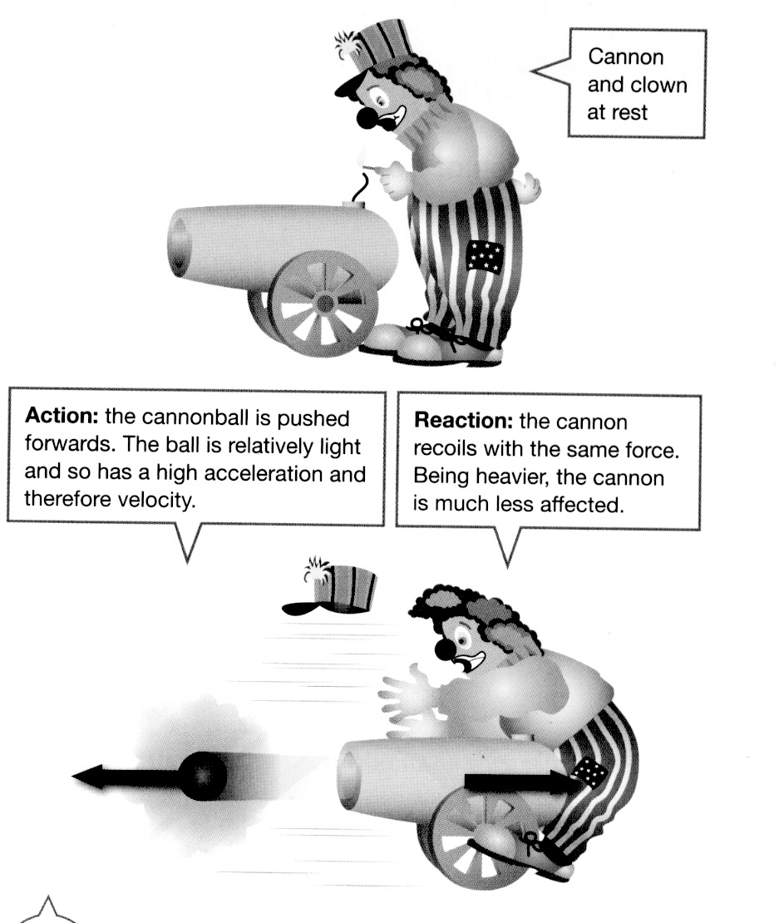
12. Look at the diagram showing a clown and a cannon at a circus.

(a) Which of Newton's three laws applies to this situation? (1 mark)

(b) Explain clearly why the cannon hits the clown. (2 marks)

13. Tim and Peter are good friends who live in the Rivervale area. Tim was planning to walk from his place to Peter's and the map below shows their respective houses. Use the map to do the following.

(a) Trace on the map the way you would walk to Peter's house. Using the scale, calculate (approximately) the distance you would walk. (2 marks)

(b) Use the scale to determine the displacement and bearing from Tim's house to Peter's house. Remember to draw the compass directions on the map.
(3 marks)

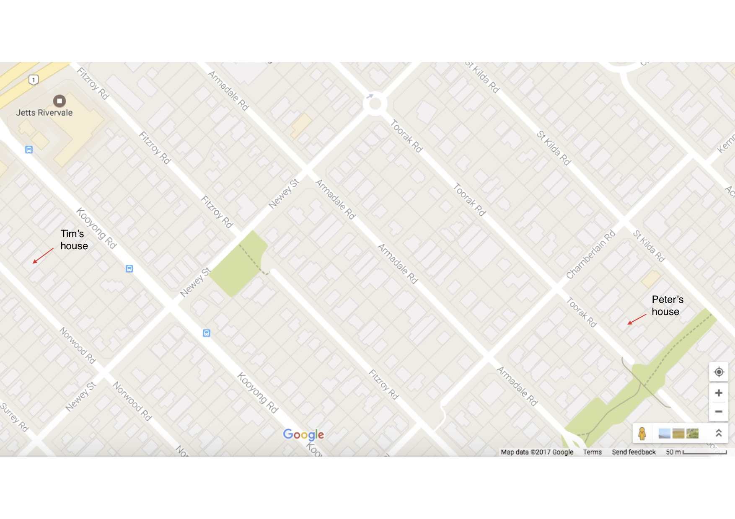
SECTION 3 COMPREHENSION (10 marks)

Read the article and then answer the questions that follow. Write your answers in the spaces provided.

Black Holes

To escape from the Earth's surface, an object would have to travel upwards at or faster than the escape velocity. This is over 11 kilometres per second. You could not throw a ball so hard!

Every space object - star, planet, asteroid or comet - has a mass and radius. These two properties determine the escape velocity for that object. The smaller the mass, the weaker the attraction of gravity is for a given radius. The smaller the radius, the stronger the gravity attraction is for a given mass. For example, the Moon's escape velocity is much less than the Earth's, at about 2.4 kilometres per second.

Black holes are objects with huge mass but very small radius. Material inside a black hole is incredibly dense because the intense gravity makes even atoms collapse in on themselves, leaving no empty spaces at all. The incredibly strong gravity at the surface of a black hole makes the escape velocity greater than the speed of light (300,000 kilometres per second).

Strangely, while a black hole is completely invisible, the space around it may be brilliantly lit up. The intense gravitational attraction of a black hole tends to pull matter into it from outside. This is most evident when a black hole has a companion star in orbit around it. Matter from a companion star falling into a black hole gives off energy as electromagnetic radiation (light), especially X-rays. The rate at which matter falls into a black hole varies, so the energy given off varies as well. Thus, some black holes tend to be strong but variable emitters of X-rays.

1. What is the escape velocity of: (2 marks)

(a) the Earth.

(b) the Moon.

2. What two factors affect the size of gravity of objects found in space, such as stars and planets? (2 marks)

•

•

3. Given your answer to question 2 above, why do black holes have such a high gravity? (2 marks)

4. Explain why black holes are so dense.
(2 marks)

5. (a) "Strangely, while a black hole is completely invisible, the space around it may be brilliantly lit up." What causes the space around a black hole to light up?
(1 mark)

(b) What is the main type of electromagnetic radiation (light) given off around a black hole? (1 mark)

END OF EXAMINATION
ADDITIONAL WORKING SPACE

